## Start with the name of **(ALL Mighty ALLAH)**

# **Dims E-project**

**A C K N O W L E D G M E N T**

We are really grateful because we managed to complete our

E-Project with in the time given by our teacher Sir Shabbir Ahmad.

This assignment cannot be completed without the effort and co-operation from out group members, Aadesh, Hamza, Usama and Zaheer.

We also thank our teacher Sir Shabbir Ahmad for the guidance and encouragement in finishing this project and also for teaching us in this course.

Last but not least, we would like to express our gratitude to our friends and respondents for the support and willingness directly or indirectly to spend some times with us to fill the Questionnaires.

# **Group Information**

# **Batch Code: PR-201901C+01C1(MWF)**

# Faculty**: Sir Shabbir Ahmad**

# **Group Member**

# **Mohammad Usama------------1171134**

# **Hamza Farooq-------------------1171132**

# **Mohammad Zaheer Soomro--1170334**

# [**Aadesh Mangliya**](https://www.facebook.com/adeshmangliya04)**-----------------1171134**

**E-Project**

# **Index**

# **Introduction**

# **Objectives of the project**

# **Problem Statement**

# **Deliverables**

# **Hardware/ Software Requirement**

**Introduction**

The thirst for learning, upgrading technical skills and applying the concepts in real

life environment at a fast pace is what the industry demands from IT professionals

today. However busy work schedules, far-flung locations, and unavailability of

convenient time-slots pose as major barriers when it comes to applying the concepts

into realism. And hence the need to look out for alternative means of

implementation in the form of laddered approach.

The above truly pose as constraints especially for our students too! With their busy

schedules, it is indeed difficult for our students to keep up with the genuine and

constant need for integrated application which can be seen live especially so in the

field of IT education where technology can change on the spur of a moment. Well,

technology does come to our rescue at such times!!

Keeping the above in mind and in tune with our constant Endeavour to use

Technology in our training model, we at Aptech have thought of revolutionizing the

way our students learn and implement the concepts using tools themselves by

providing a live and synchronous E-Project learning environment!

## **So what is this E-Project?**

E-Project is a step by step learning environment that closely simulates the classroom

and Lab based learning environment into actual implementation. It is a project

implementation at your fingertips!! An electronic, live juncture on the machine that

allows you to

1. Practice step by step i.e. laddered approach.
2. Build a larger more robust application.
3. Usage of certain utilities in applications designed by user.
4. Single program to unified code leading to a complete application.
5. Learn implementation of concepts in a phased manner.
6. Enhance skills and add value.
7. Work on real life projects.
8. Give a real life scenario and help to create applications more complicated and
9. useful.
10. Mentoring through email support.

# **How do we start accessing the Sample E-Project?**

The students at the center are expected to complete this E-Project and send complete

documentation with source code within the time allotted to E-Projects Team

Looking forward to a positive response from your end!!

**Objectives of the project**

The Objective of this program is to give a sample project to work on real life

projects. These applications help you build a larger more robust application.

The objective is not to teach you the software’s but to provide you with a real life

scenario and help you create basic applications using the tools.

You can revise the topics before you start with the project.

These programs should be done in the Lab sessions with assistance of the faculty if

required.

It is very essential that a student has a clear understanding of the subject.

Kindly get back to E-Projects Team in case of any doubts regarding the application or

its objectives.

# **Introduction**

The problem statement is attached separately in a file “Symphony Limited.doc”

Standards plan:

1. Every code block must have comments.

2. The logic of the program needs to be explained. Proper documentation should

be maintained.

3. Complete Project Report along with synopsis, code and documentation should

be prepared.

Note: Don’t forget to take your data backup every day. This will save your project

work from the following:

a. Virus problem

b. System failure

c. File corrupt

Data Backup is an important event to be done on regular basis in a project

management.

# **Documentation**

No project is complete without documentation. In fact, it is one of the most

important activities during the development of a project. The documentation of an

ideal project will be in the form of a project report comprising of the following

documents:

* Certificate of Completion.
* Table of Contents.
* Problem Definition.
* Customer Requirement Specification.
* Project Plan.
* E-R Diagrams.
* Algorithms.
* GUI Standards Document.
* Interface Design Document.
* Task Sheet.
* Project Review and Monitoring Report.
* Unit Testing Check List.
* Final Check List.

**Deliverables**

You need to submit the following Deliverables:

1. Documentation of the project.
2. You need to follow all the following points as a part of your E-projects execution process

a) Send us 2 (two) E-projects status mail, each should be after 10 days

interval from your E-projects start date. Incase if your project is less than 30

days then also you need to send 2 (two) status mails (first status mail between 7-10 days and second 3 days before the end date of project).

b) The status mail should consist of description with review document (Whats going on the project). Also you can send your doubts / clarification or any additional inputs required to complete your E-project any time during the project planning and execution.

c) At the time of project submission also send us the feedback along

with your documentation (soft bound copy). The Feedback form is attached

with this mail.

Remember that the subject of your email should start either with the word STATUS:

or DOUBT: or PROJECT SUBMISSION: accordingly.

**Hardware/ Software Requirements**

# **Hardware**

1. A minimum computer system that will help you access all the tools in the

courses is a Pentium 166 or better

2. 64 Megabytes of RAM or better

3. Windows 98 (or higher if possible)

4. Java Virtual Machine

# **Software**

Either or combination of the following Software’s are to be used:

▪ Notepad/HTML editor/Java editor

▪ Dream weaver/JavaScript

▪ j2sdk1.4.1_02 (or later) / .Net / J2EE

▪ JSP / Servlets

▪ EJB / Struts

▪ JDBC

▪ SQL Server 2000 (or later) / Oracle 9i / MS Access

▪ JDBC Driver

**SYMPHONY LIMITED**

# **Table of Contents**

Introduction ………………………………………………………………………………...02

Existing Scenario ……………………………………………………………………….….02

Proposed Scenario ………………………………………………………………………..02

Non-Financial ….…………………………………………………………………………….03

Financial.………………………………………………………………………………………..04

Functional Requirements ……………………………………………………………...04

**Introduction: –**

Symphony Ltd. is private institute, which generally conducts the classes and training

materials for the various certifications that are related to IT and Software industries like

networking related, Java related, database related like for SQL Servers, oracle, etc. They

are one of the famous institutions which have spread in to various branches situated at

different location in the state.

They provide various resources like the preparation materials, lab facilities based on the

subject, extra lab hours or sessions (offered after the course duration), 24 hours faculty

guidance is provided for the lab sessions, assignments, Library facilities, etc.

**Existing Scenario: –**

Currently they advertise about the services that they provide through the pamphlets

(available at the centres), advertisements in news papers, and through other media like

through television advertisements, etc. in order to attract the people. Usually they conduct

the trainings on half yearly basis every year.

They generally conduct an entrance exam through which they can know the knowledge

level of the participant and thus depending on the exam marks they segregate the

participants or the students into the appropriate class rooms like for the participant not

having the minimum knowledge will be given training right from the basics till the

certification level and for the participants having the minimum knowledge about the

basics will be segregated in to the class where they direct start with the basic certification

topics with out touching the basic concepts of the subject.

Once the examination results are out, they inform the participants with the results, and

ask them to visit the institution on a particular date for counseling purpose, where they

inform the students with which class they will be segregated and regarding the course

fees based on the class segregated. If the student is interested in taking the class, then he

will be provided with the class form in which he/she is segregated and then they are

directed to the accounts department where the student needs to make the payment in

order to join the class. The student can make the payment for the class, at least 1 day

before the commencement of the class.

For the training with the basics they usually charge around 6000$, and the duration for

the training will be for 6 months. And for the training with out the basics they charge

around 4275$, and the duration will be for 4 months.

They also provide the practice sessions (extra lab sessions) separate from the course

duration, i.e., after the successful completion of the course if the student wishes to

practice the lab sessions at the lab in the institution, he (student) can prefer at the time of

registering for the course. And for this they charge around 1000$ separately from the

course fees. But the student has to opt it at the time of getting registered for the course

itself. Else if student wants to opt for it at the end of the course based on his requirement,

then they will charge 1500$.

Note: The extra lab sessions are only available for the students who have registered for

the course offered by the institution. And for this they provide guidance too by one of the

faculty members.

After the completion of the certification course, they conduct the final examination and

based on the marks secured the respective faculty members provides the suggestions and

feedback like what are areas of improvement, where extra practice is to be delivered,

which other materials apart from the course materials can be preferred, etc. Thus,

ensuring that they pay maximum attention to the students and making the student

benefited for joining this institution.

For going into the library that the institution provides, the student must display his

identity card. And they do not allow the student to carry out the library books to his / her

house.

**Proposed Solution: –**

Right now they want to incorporate online systems through which they can advertise

about the services that they provide and thus ensuring that they gain the attention of the

certification aspirants up to a maximum extent. So they have approached us so that we

can provide an online portal where the different functions of the institution are displayed.

**►Non-Financial:**

They want the following functionalities to be incorporated on the portal.

1. There should be an admin login provided apart from the normal site function,

where the admin can enter the following information:

* List of the courses offered and the topics that are covered.
* New courses if any
* The Entrance Examination Information
* Displaying the results. On this page the admin should be able to enter the

student’s details like the roll number, name and the marks secured by

him/her and the class into which he/she is segregated, and the fees details

with respect to the class that the student is segregated into.

* About us (on this page the admin can enter or update the information about

the institution)

* FAQ’s Page (On this page the admin should be able to enter, update or

delete the FAQ’s)

1) How to join the course? (On this the admin should be able to

enter or update the procedures for joining the course that the

institute offers)

2) Why to join the institute? (The various benefits that the student

can gain by joining the institution is to be provided)

3) When will be Entrance Examinations Conducted? (Once in 6

months, and one need to check the website for knowing when is

the entrance exam entitled, the fees for the entrance exam (admin

will decide and displayed on the application form), etc. are to be

listed

4) Can I use the Lab facilities after my class hours? Will there be

any extra hidden charges? (Ans: Yes, you can use the lab

sessions even after your class hours. There will be no charges

during the course days (i.e., during the course period if you want

to use the lab sessions after the class hours we do provide the lab

session and the labs will be kept opened till 9 PM in the evening.

But yes if you want to use the lab session after your course

completion, then it will be charged based on the scenario (like

1000$ if opted at the time of registering and 1500$ if opted after

the completion of the course)

5) How can I apply for the entrance exam? (Ans: once the entrance

exams are entitled, one need to visit the centre for applying it

through paper and fill all the necessary details through online. On

the application form one should chose which course he/she

wanted to pursue.)

6) Will there be any fees for the entrance exam? (Ans: Yes there

will be and it will be available on the application form)

7) How to make the payment? (Ans: payment can be done through

draft, or through cheque or through cash. For making the

payment through cash, one needs to come to one of the centre of

the institute, and make the payment there itself. Once the

payment is done (through cash or through DD), the student will

be provided with the receipt with a receipt number. This receipt

number is to be inputted in the application form. For the

payments done through cheque and DD, one need to enter the

DD number and the cheque number, bank details, etc. are to be

entered on the application form and the cheque is to be pinned to

the application form. Only once the payment is received the

student’s application will be accepted. Once the application is

accepted, the student is mailed with the acknowledgement form

along with the details of the examination, subject chosen, date

and time of exam, and the roll number).

* Contact Us Page (on this page, the admin should be able to enter or update

or delete the list of the centres of different branches that are available and

their addresses along with the telephone numbers)

2. The normal site function should have the following

* Home page (On this page the brief description of the institute and that of

the courses offered, new course details, etc. are to be displayed.

* About Us
* Course details (on this page the list of the various courses offered are to be

displayed along with the topics that each course covers)

* Entrance Examination (on this page one should be able to view the details

of the upcoming entrance examinations, and the results of the last exam

that is conducted. For viewing the results one must click the link which

will direct to the page that asks for the roll number, now the student must

enter the roll number which is provided on the acknowledgement card after

the acceptance of his/her application. If the student’s roll number is

existing then the result secured by the student will be displayed, else a

message stating that there is no such roll number in the database is to be

displayed. Along with the result of the student, the class he/she has been

segregated to and the course fees based on the class segregated are to be

displayed and the last date for making the payment is to be displayed)

* FAQ’s
* Contact Us (the list of the various centres located at different places will be

displayed)

►Financial:

The course fees, entrance exam fees will be decided by the admin alone. They can be

varied from time to time.

Functional Requirements: –

1. There should be two functionalities

* Normal site functionality for viewing the various functionalities offered by

the centre, and

* The admin functionality for entering, updating and deleting the details of

the various functionalities like the course details, entrance exam details,

results details, FAQ’s, and contact information.

2. The database should hold the details of the courses, students who registered for

entrance exam and their results, centre details, FAQ’s, etc.

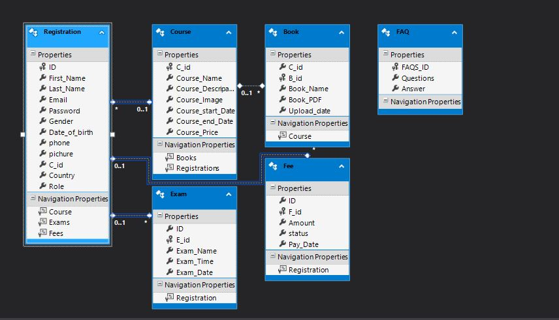E-R DIAGRAM:

DFD DIAGRAM (User Guide)

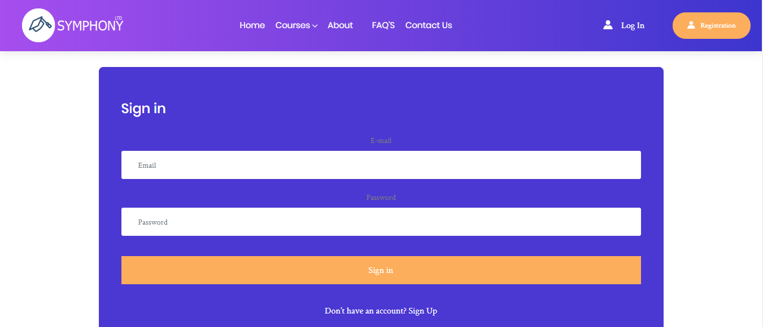

DASHBOARD:

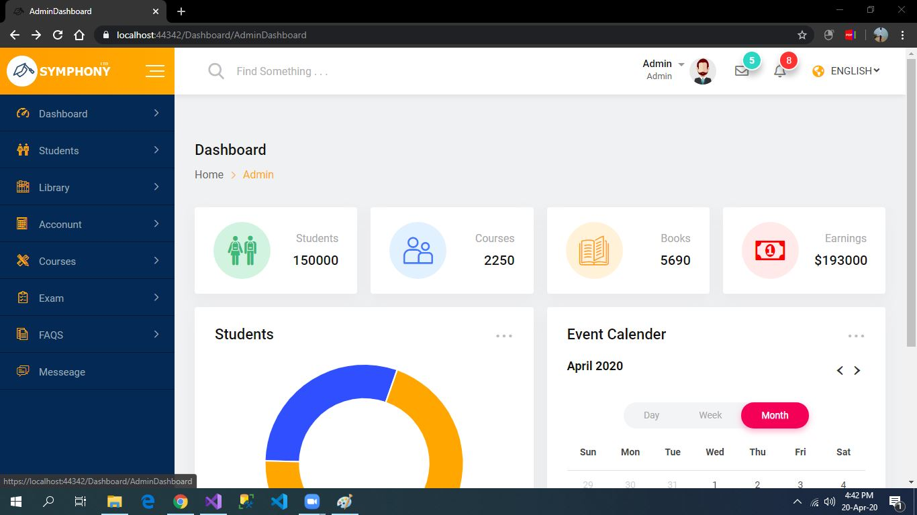

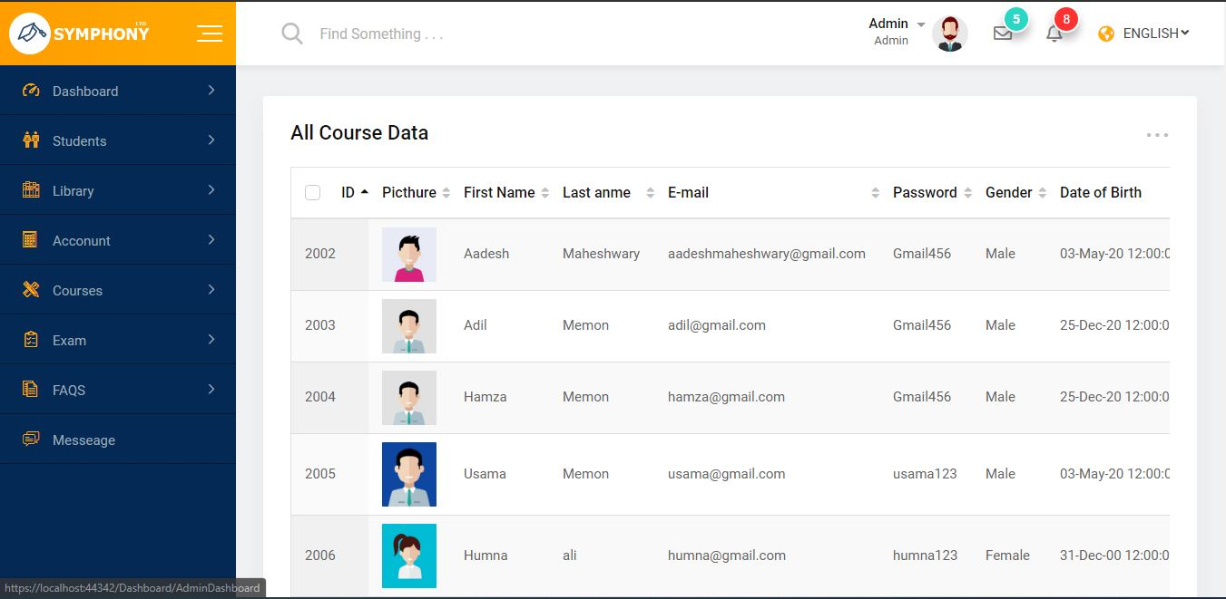DASHBOARD (Student):

DASHBOARD(BOOK):

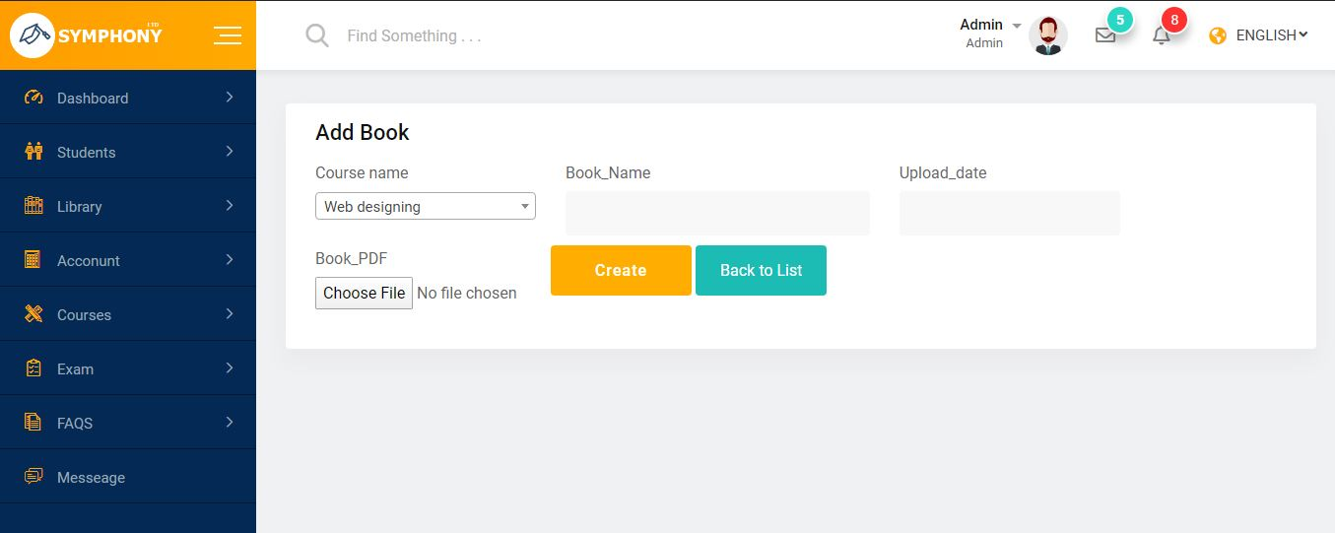

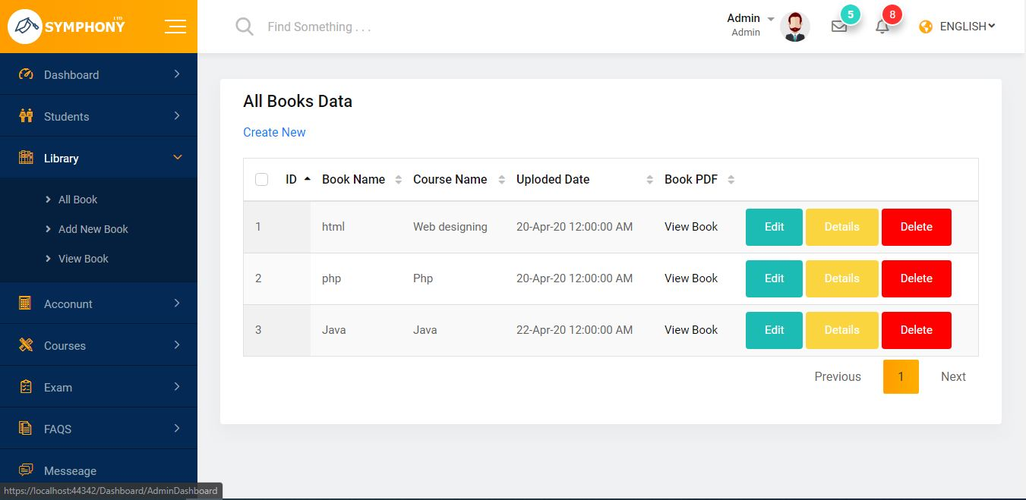

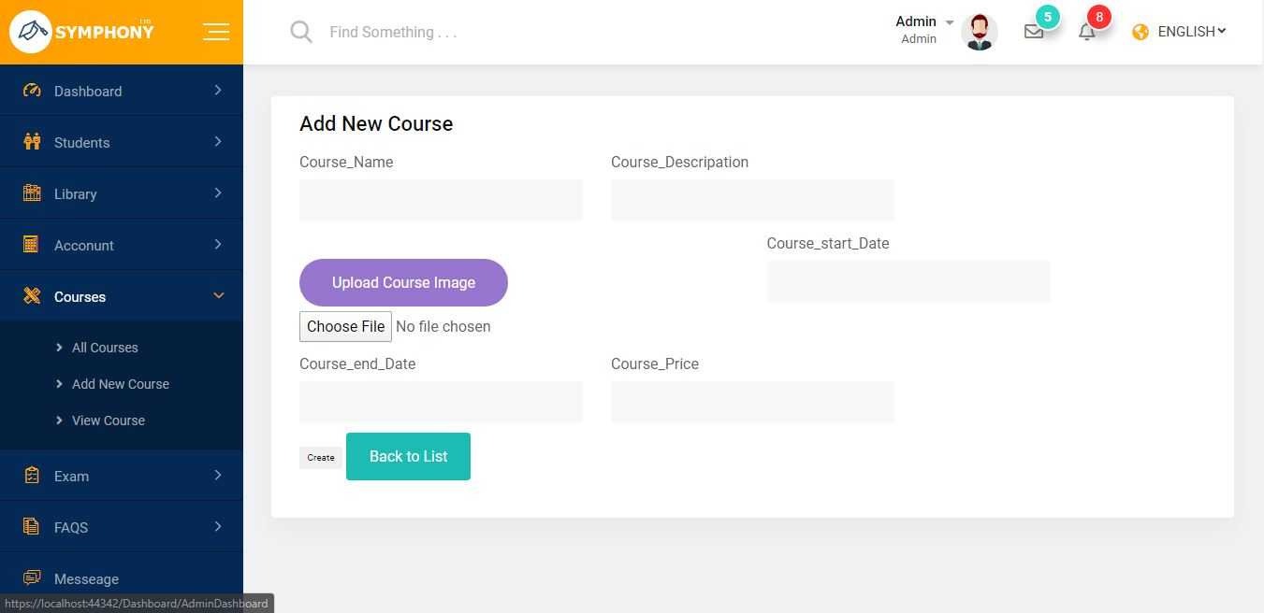DASHBOARD(Course):

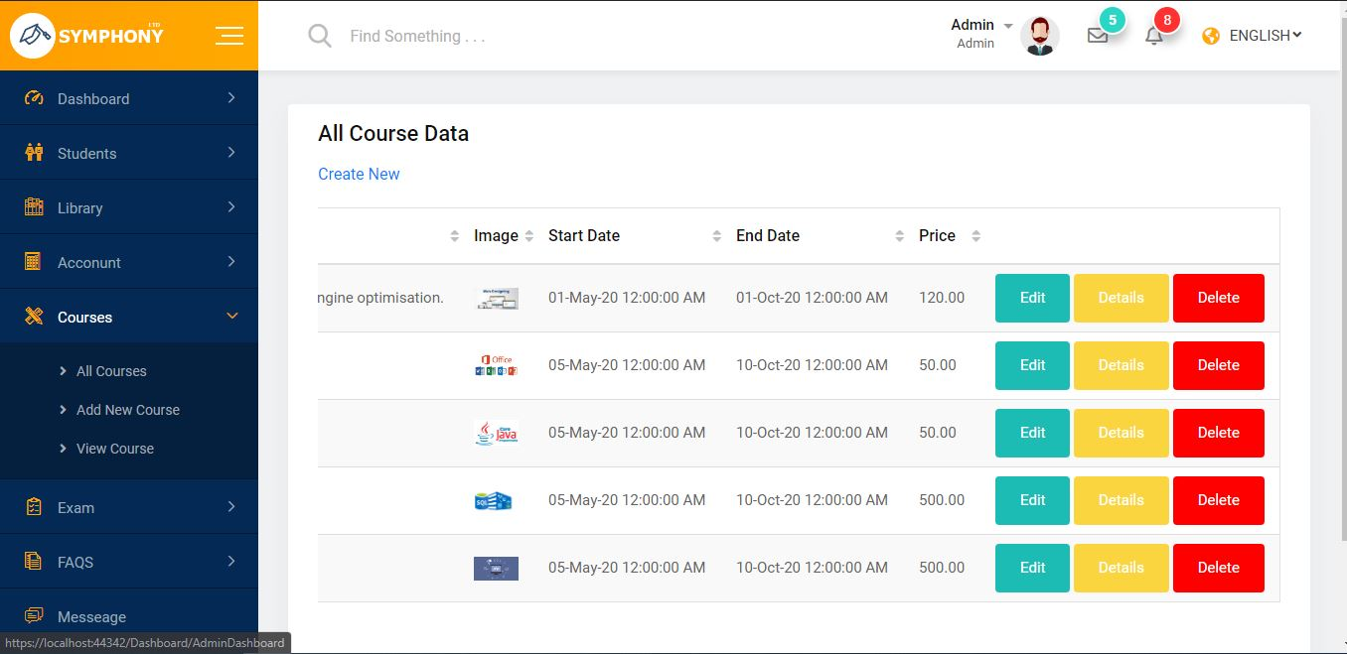

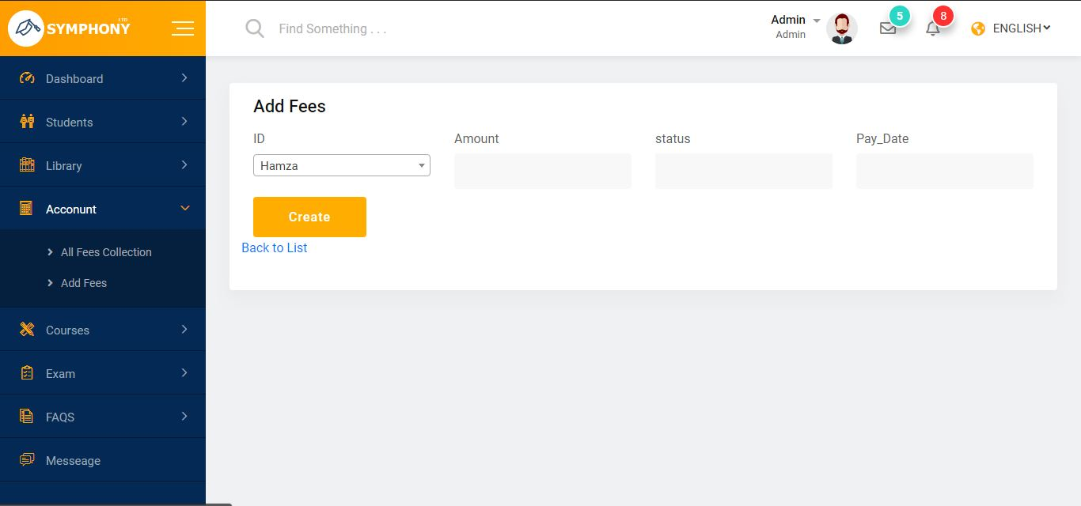DASHBOARD(Fees):

DASHBOARD(Exam):

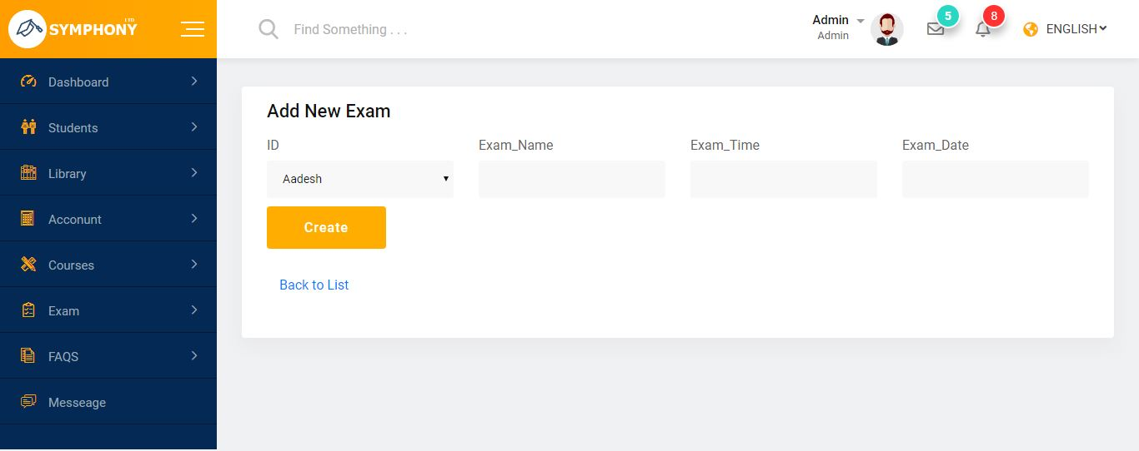

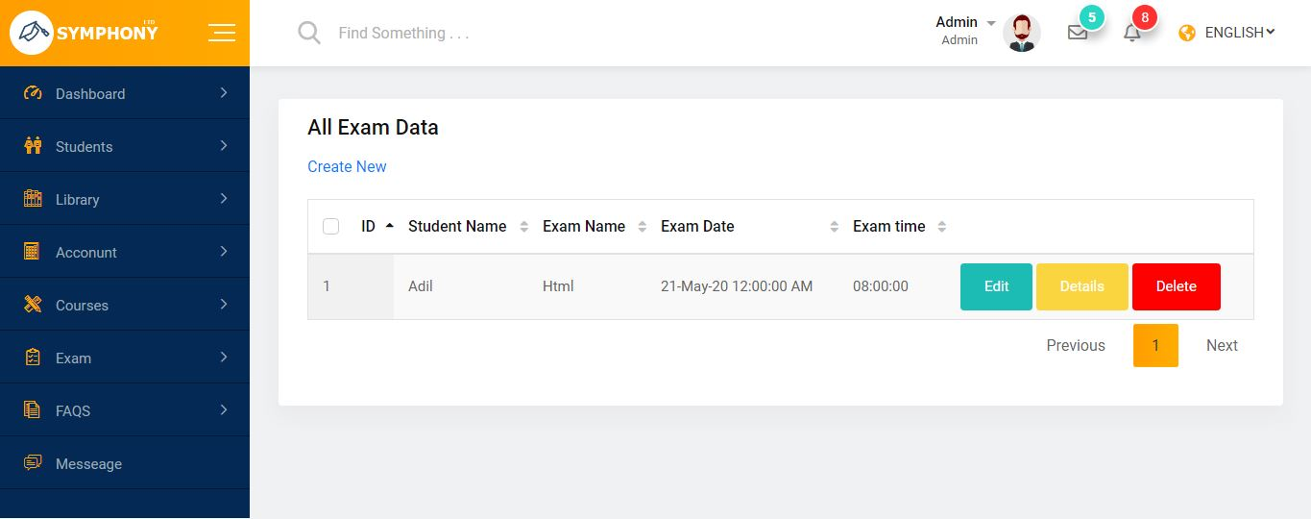

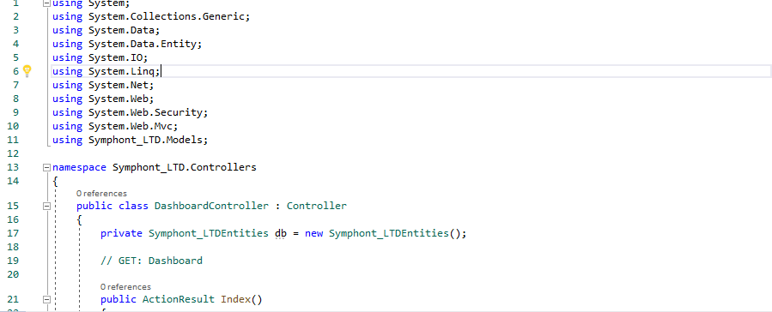DASHBOARD CONTROLLER CODING:

